Grazioso Salvare Search and Rescue Dashboard
CS 340 Project Two — README
Brian Minor

Project Overview
This project provides Grazioso Salvare with a web dashboard for reviewing Austin Animal Center Outcomes records and identifying dogs that may qualify for search-and-rescue training. The dashboard retrieves shelter records from MongoDB using the AnimalShelter CRUD module developed in Project One. Users can switch between rescue categories, examine a sortable and paginated table, review a breed distribution bar chart, and locate a selected animal on a map.

Features and Client Requirements
- Four radio-button choices: Water Rescue, Mountain or Wilderness Rescue, Disaster or Individual Tracking, and Reset (all records).
- MongoDB queries filter by dog type, preferred breed, sex upon outcome, and age in weeks.
- Interactive table provides ten rows per page, sorting, built-in column filtering, and single-row selection.
- Breed distribution bar chart summarizes the top ten breeds in the currently visible filtered table.
- Leaflet geolocation map displays the location of the selected animal (or first available animal when none is selected).
- Dashboard includes the Grazioso Salvare logo linked to https://www.snhu.edu and the developer identifier Brian Minor.

Rescue Selection Rules
Rescue type | Preferred breeds | Sex | Age (weeks)
Water | Labrador Retriever Mix; Chesapeake Bay Retriever; Newfoundland | Intact Female | 26–156
Mountain/Wilderness | German Shepherd; Alaskan Malamute; Old English Sheepdog; Siberian Husky; Rottweiler | Intact Male | 26–156
Disaster/Tracking | Doberman Pinscher; German Shepherd; Golden Retriever; Bloodhound; Rottweiler | Intact Male | 20–300
Source: CS 340 Dashboard Specifications Document, “Rescue Type and Preferred Dog Breeds Table,” page 4. The application matches preferred breed text within the shelter breed field, which can include mixed-breed descriptions.

Tools and Design Rationale
- MongoDB stores animal records as flexible BSON documents and supports targeted searches by animal type, breed, sex, and numeric age. PyMongo supplies the Python interface for querying the collection.
- The ProjectOne_CRUD_Python_Module.py AnimalShelter class encapsulates database access. Its read(query) method is reused by the dashboard instead of duplicating MongoDB connection code.
- Python and pandas convert MongoDB documents into tabular records; MongoDB _id values are removed before passing data to Dash to avoid ObjectId serialization errors.
- Dash and JupyterDash provide the dashboard layout and reactive callbacks: radio-button selections trigger database queries, and the table’s derived data drives both visualizations.
- Plotly Express produces the breed-count bar chart; dash-leaflet provides the geolocation map. JupyterLab in Codio provides the development and execution environment.

Model–View–Controller Organization
Model: the MongoDB aac database and animals collection, accessed through the AnimalShelter CRUD module. View: Dash radio buttons, data table, chart, map, logo, and headings. Controller: Dash callbacks construct the rescue queries, update table records, and redraw the chart and selected-animal map when table data or selection changes.

Reproduction Instructions
1. Open the CS 340 Codio workspace and locate the code_files directory.
2. Confirm MongoDB is running and the aac.animals collection contains the Austin Animal Center Outcomes dataset, including location_lat, location_long, and age_upon_outcome_in_weeks. In the demonstrated environment, 10,000 documents were available.
3. Ensure ProjectOne_CRUD_Python_Module.py and ProjectTwoDashboard.ipynb are together in code_files. Place the supplied Grazioso Salvare Logo.png there as well.
4. Install or confirm the Python packages required by the notebook: pymongo, pandas, dash, jupyter-dash, dash-leaflet, and plotly. Use versions compatible with the Codio environment.
5. In the private course environment, configure the aacuser MongoDB credentials used to instantiate AnimalShelter. The submitted course notebook uses assignment credentials; do not commit those credentials to a public repository.
6. Open ProjectTwoDashboard.ipynb in JupyterLab, restart the kernel, and run all cells. Verify the MongoDB connection message and that the official logo loads.
7. Open the Codio proxy link printed by JupyterDash (the demonstrated app uses port 8060).
8. Test Water, Mountain/Wilderness, Disaster/Tracking, and Reset. Confirm the record counts, table, breed chart, and map respond. Select different rows to verify map changes.
9. Capture the dashboard’s starting state and each of the four required filter states with logo and identifier visible. Include the screenshots in this README.

Testing Results and Evidence
The following record counts were observed after adding the preferred-sex requirements to the MongoDB rescue queries. The screenshot evidence below documents the dashboard states.
Selection | Records displayed | Evidence
Water Rescue | 17 | Screenshot included below
Mountain/Wilderness | 19 | Screenshot included below
Disaster/Individual Tracking | 28 | Screenshot included below
Reset / All Animals | 10,000 | Screenshot included below
The full-dashboard PNG screenshots show the logo, developer identifier, selected rescue category, record count, data table, breed chart, and map together. The logo hyperlink and row-selection map behavior were also tested successfully.
Initial Dashboard — Unfiltered View
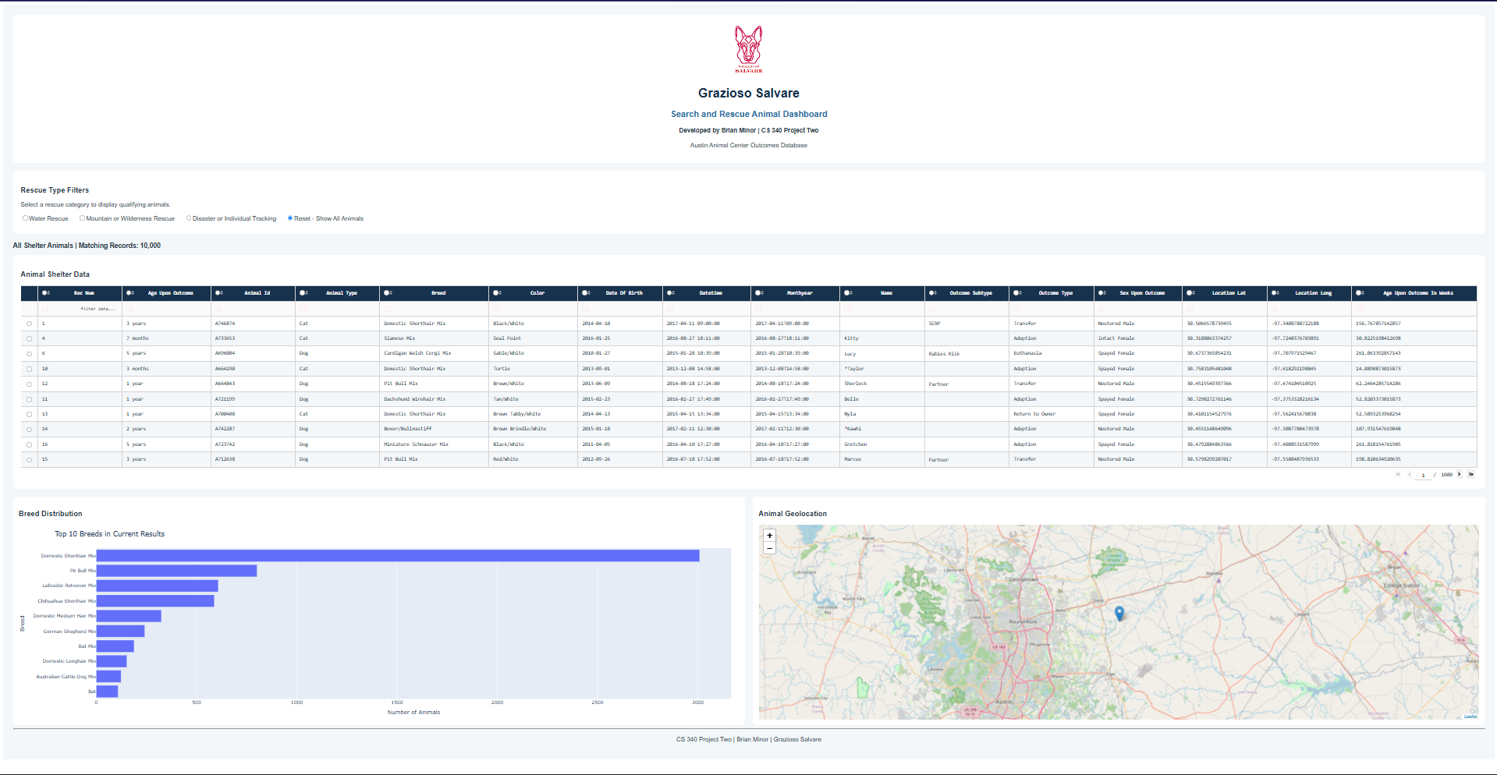

Water Rescue — 17 Matching Records
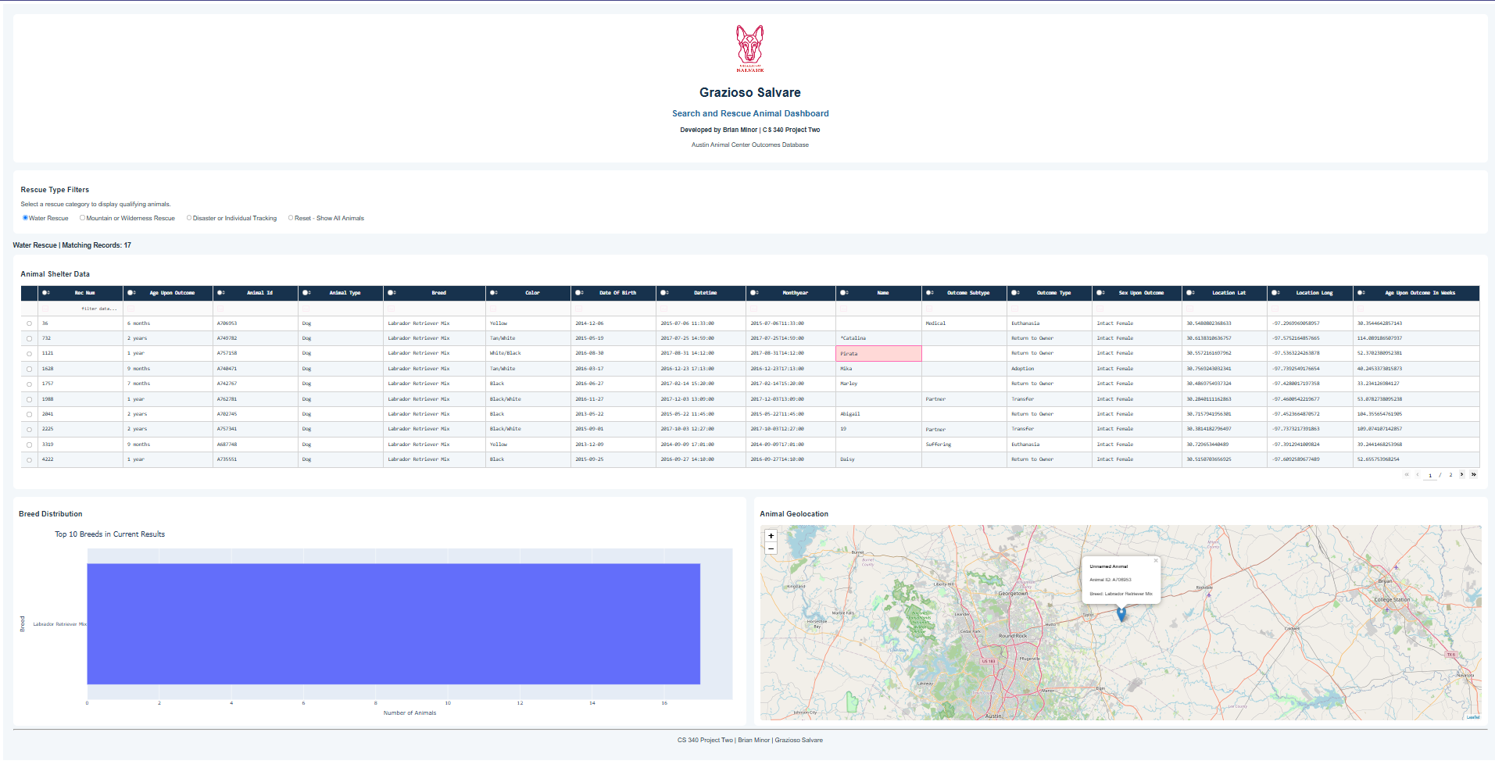

Mountain or Wilderness Rescue — 19 Matching Records
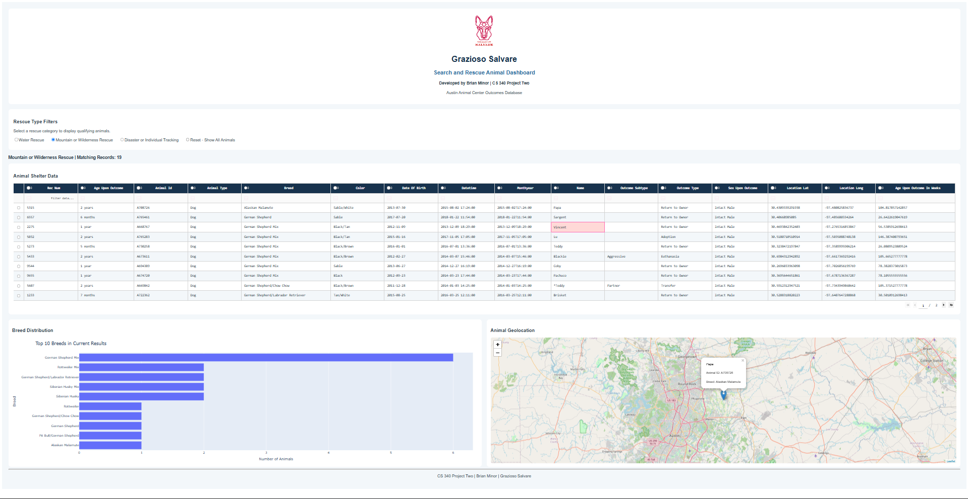

Disaster or Individual Tracking — 28 Matching Records
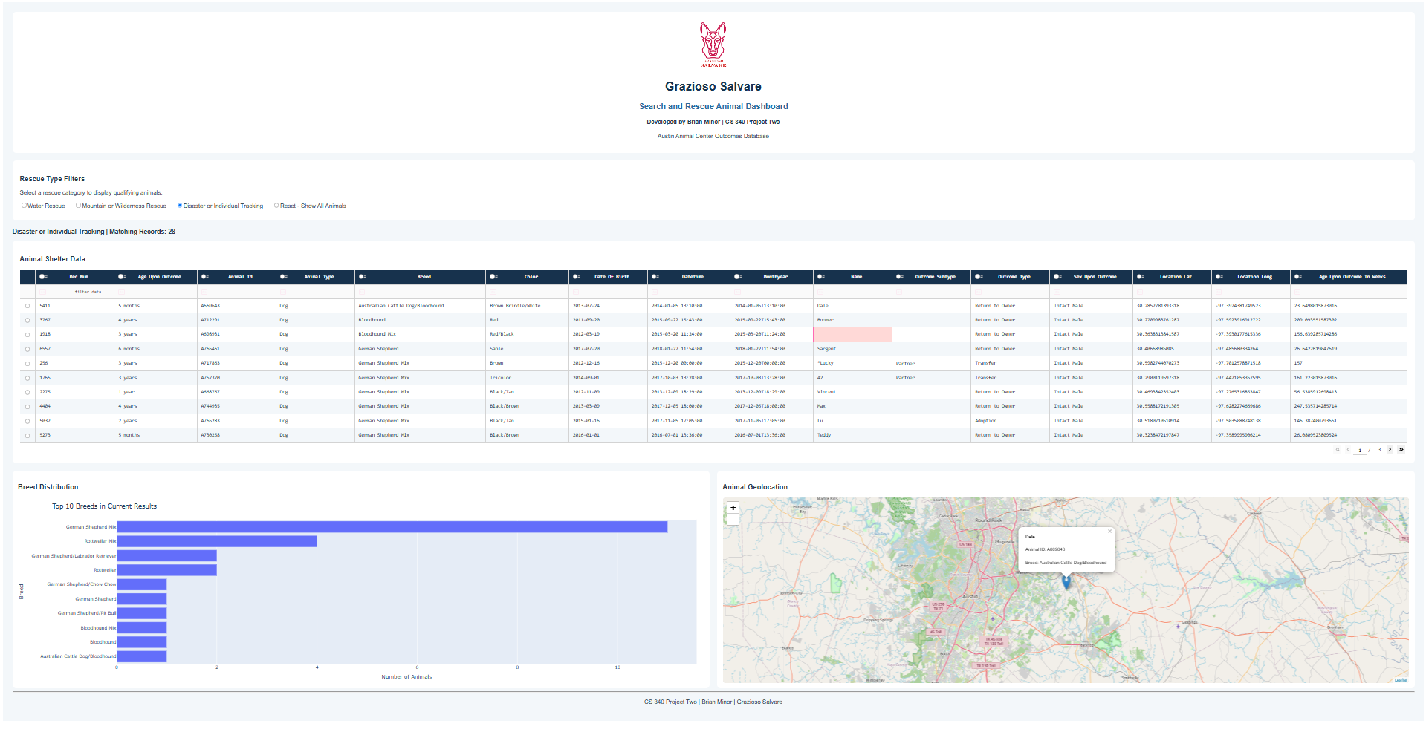

Reset — All 10,000 Records

Challenges and Solutions
- MongoDB ObjectId values cannot be directly serialized in the Dash table. Solution: remove the _id column from records before rendering.
- The original rescue queries filtered breed and age but omitted the preferred sex. Solution: add sex_upon_outcome to the query using the specifications table; the updated results were 17, 19, and 28.
- The dashboard needed to reuse Project One database logic. Solution: import AnimalShelter from ProjectOne_CRUD_Python_Module.py and call read(query) for all filtered retrievals.
- A running Jupyter notebook may conflict with an earlier Dash server port. Solution: launch on port 8060 and open the Codio proxy URL.
- The original PDF exports split the dashboard and caused chart/map overlap. Solution: capture full-dashboard PNG screenshots at a reduced browser zoom and use those images in this README.

Project Files
- ProjectTwoDashboard.ipynb — Contains the interactive dashboard, rescue filters, data table, and visualization components.
- ProjectOne_CRUD_Python_Module.py — Provides the MongoDB connection and CRUD functionality.
- Grazioso Salvare Logo.png — Contains the official logo displayed on the dashboard.

References and Software Links
CS 340 Dashboard Specifications Document (course-provided PDF).
Austin Animal Center. (2020). Austin Animal Center Outcomes [Data set]. City of Austin, Texas Open Data Portal. https://doi.org/10.26000/025.000001
MongoDB documentation: https://www.mongodb.com/docs/
PyMongo documentation: https://pymongo.readthedocs.io/
Dash documentation: https://dash.plotly.com/
Plotly Python: https://plotly.com/python/
Dash Leaflet: https://www.dash-leaflet.com/
Python PEP 8: https://peps.python.org/pep-0008/

